My Latest Thrifting Trip
This past weekend I did something I had not done in quite some time. Hubs and I took a day and spent it together thrifting. We had a ball. We got up and out around 10:00 and it was an all-day adventure of finding treasures.
We began our adventure at our local flee market. We purchased our produce from local farmers for the week and while there we lucked up on two awesome iron based bar stools with backs no less for $40.00. I do not have a bar, but I thought these would be perfect on our deck for extra seating. They are sleek, can be easily painted any color we like, the seat covers are easily changed and the price was right…or so I thought until I traveled further. Stay tuned. At any rate, we purchased the bar stools and even though we’ve had a few days to reflect, there is no buyer’s remorse. These will look different when you see them next.
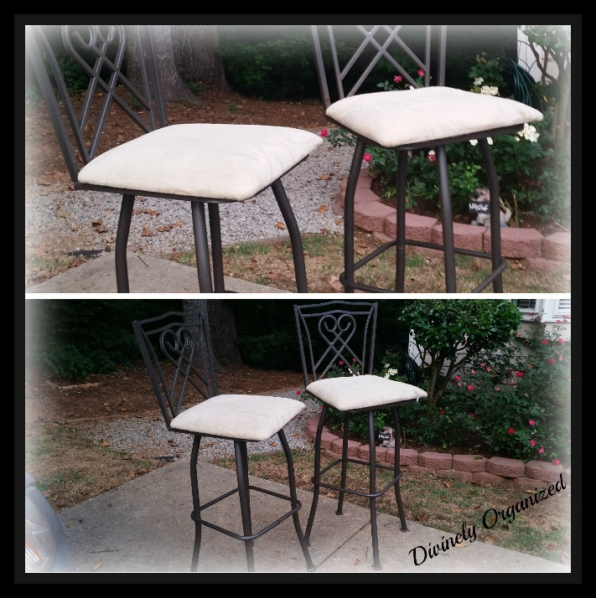
Earlier during the week, I had heard of a new place that opened and it was dubbed the DIYer’s paradise. So we headed over to the Scrape Exchange. This place is amazing and filled to the rafters with “stuff.” Everything from wallpaper sheets sold by the ounce, paint sold by the ounce, paint brushes, ribbon, sewing notions, glass bottles, stained glass pieces, photographer backgrounds, easels, and much, much more. There is more “stuff” than you can imagine. We were in awe, but the amazing things were the prices were so very reasonable.
I am teaching myself to decoupage and what better way to practice than with bottles that cost $1.00 or less and wallpaper pieces that are sold by the ounce? I am going to have a ball with this. I also purchased the cookie tins with a project in mind. Not sure how I’m going to make this one work. I am still thinking this project through. Stay tuned because although they will look very different, you will see these tins again.
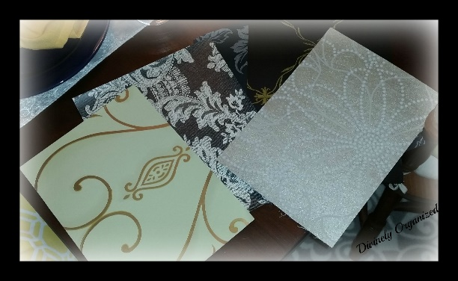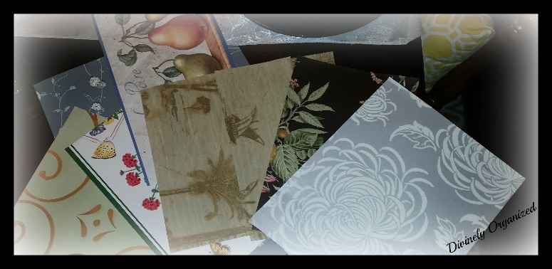
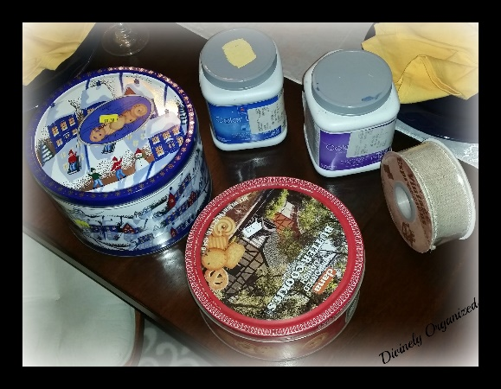
I was very impressed with the fact that they weigh the paint. It sold for $.25 a pound and I got the two jars above for a little over $1.00. Each were full. As you will see below, they also had paint brushes and everything else one could think of.
The used brushes were only $.25 (clean and great quality) and the ones in the plastic bag, never used, were $1.25 and they are really good, natural bristle brushes as well. The ribbon and cabinet pulls were reasonable and I haven’t a clue of the exact price of the wine corks. Just suffice to say, they were “cheap.”
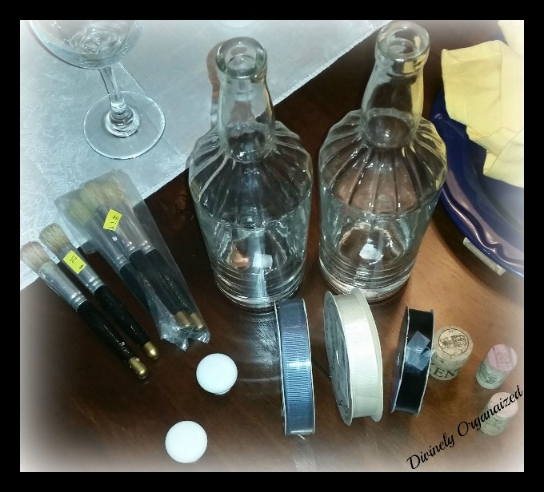
Finally, something for hubs, the easel below was only $5.00. He’s a photographer and thought he could use this for his business. After, I get it painted and pretty of course. But what a good price for this piece. All of these goodies only cost $18.38 in total. Not bad…right?
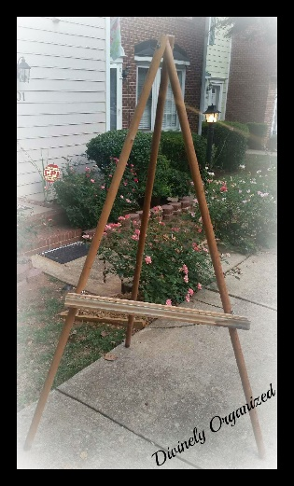
Truck packed, we were off again and decided to make one more stop at our local Habitat for Humanity outlet. Usually, I always find something here but not today. I was not discouraged, some days you hit and other days you miss and although I had hit at the previous two places, Habitat was a miss today. Better luck next time. Go figure, there is a Christian thrift store next door to the Habitat for Humanity outlet. Of course we had to go in.
Here we found a few more treasures. I added candle holders (can never have enough of those) more glassware, and…drum roll please…2 more bar stools with backs. They were only 7 dollars each. I realize we had just purchased 2 at the flea market but we could use the extra seating on the deck during family gatherings. And besides, I now have yet another project…love projects. I figured I would paint them all the same color and match the cushion fabric to make them cohesive. There was also a desk there I would have loved to have purchased, however, the SUV was filled to capacity. It was only $7.00 but I had to pass because we did not have space. That’s okay, I have enough projects for now.
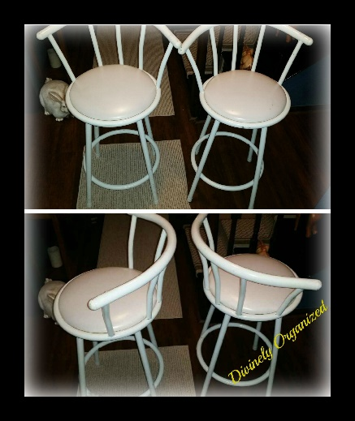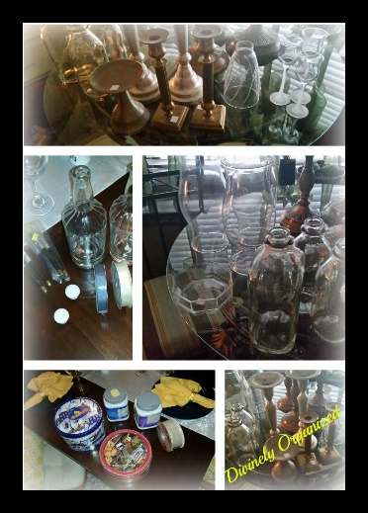
It was a very fun day. We lucked up on a few good pieces. And we did not spend a lot of money. My kind of day. We had enough left from the set budget to have a nice dinner before going home. As I said, some days you hit and other days you miss. This was a hit day for sure.
Have you had a successful thrifting day recently? If so, share your treasures and how you have transformed them.
Remember to share…

Published:

MomsMagazine.com
IBA.com
Blogher.com
Hubpages.com

