10 DIY Projects that are Perfect for Summer time
Summer has just begun and we are very excited to make the best of it! Isn’t everyone? Whether you are enjoying a sunny day at the beach, preparing refreshing drinks, or trying out these wonderful DIY and craft ideas at home, it is that time of year for laughter, family, and fun. DIY projects are a great way to relax, clear the mind, and in some cases, spend quality time with family - with the bonus of creating something amazing! Check out the DIY project ideas below that are all about providing you with some relaxation time and creating summer memories that will last forever.

Garden Lights
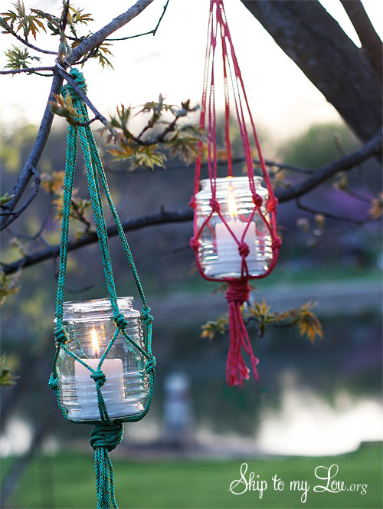
Image source: Skip to my Low

Spending time outside is one of the main reasons we love summer. So, having outdoor lightning is the least you can do to make the best out of those summer evenings. These hanging candle holders are an adorable addition to your garden landscape and you can learn how to DIY them here. And it comes with a bonus: if you use citronella candles, it will help keep the mosquitoes away!

Beach Towel Bag
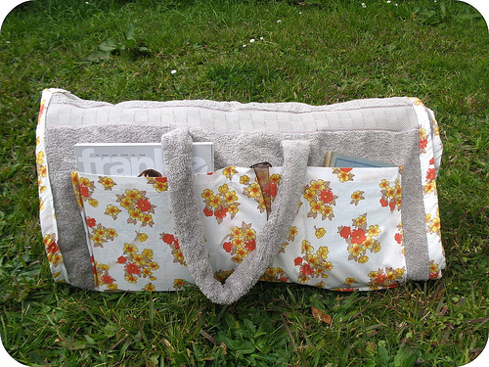
Image source: The Golden Adventures

This handy DIY project from The Golden Adventures is totally amazing! The step-by-step is very well explained and adds lots of pictures to make it easier for begginers, anyone with a couple of spare hours will enjoy making this lovely beach towel bag. It is cuuuuute!!!!

Outside Seating
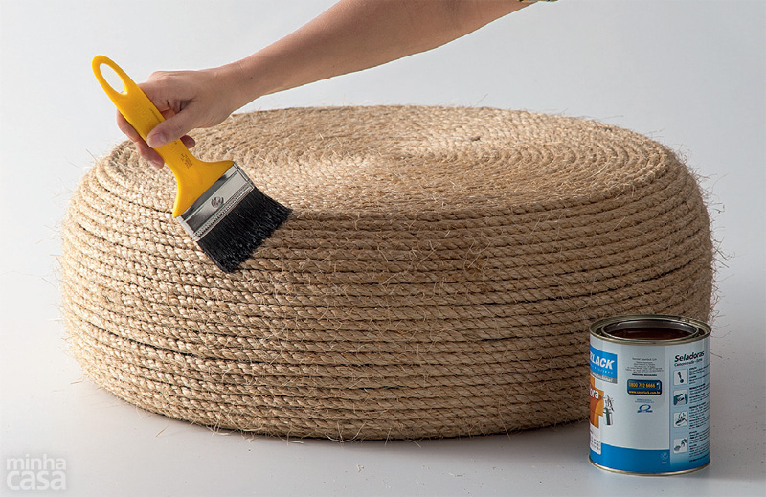
Image source: Handimania

This is a project to recycle old tires. How creative to make old tires into beautiful outdoor ottomans. You will never look at old tires the same again! :) You can be place these creative outdoor seats in your backyard to gather your family and friends on a summer afternoon! Or congregate for a lovely evening of outdoor movie watching. Handimania shows you everything you need to know to bring this project to life.

Birdhouses
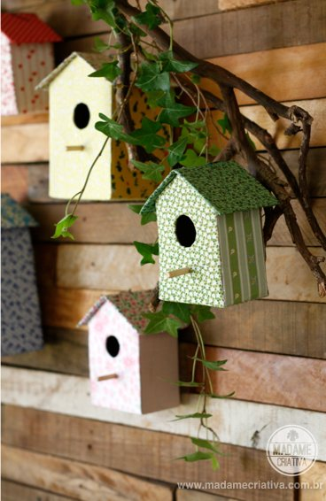
Image source: Wonderful DIY

Recycling and spending quality time with your kids can come together when creating these DIY Cardboard Birdhouses. You’ll need:

- Cardboard
- Box cutter
- Ruler
- Scissors
- Fabric
- Glue
- Small piece of wire
- Pliers
- Hot glue gun

Butterfly Feeders
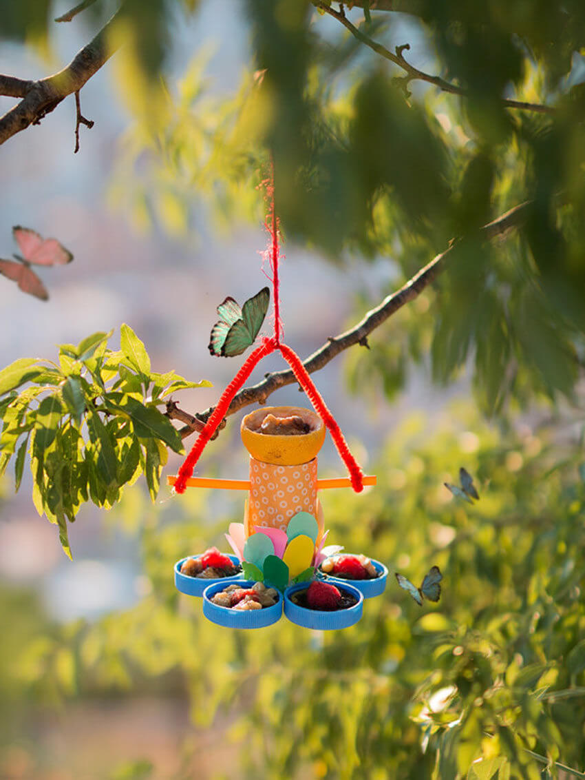
Image source: Handmade Charlotte

There’s more than one option to make butterfly feeders, but they’re all really easy to DIY at home. The one from the photo is not only cute, but also eco-friendly! Find materials and directions here. I absolutely love butterflies in my garden and adding this project to my “I gotta do this summer list” is a given.

Pinwheels
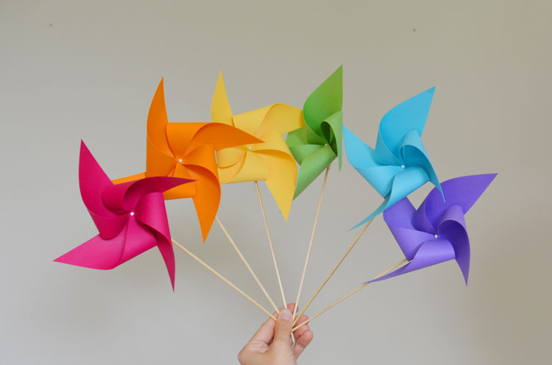
Image source: One Little Project

Pinwheels can be a lovely addition to a summer day outdoors, they are easy to make and kids love them - and we love to see our children happy, right? Materials and instructions can be found at One Little Project. In addition, pinwheels can also be a nice decor addition.

DIY Coasters
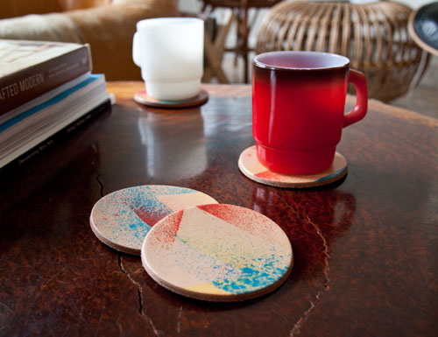
Image source: Design Sponge

Anything that combines style and function is a must on the summer to-do list, which is the case for these amazing coasters. They’ll require a bit more time to make, but so worth it! Find all the materials, supplies and instructions at Design Sponge.

Custom Beach Ball
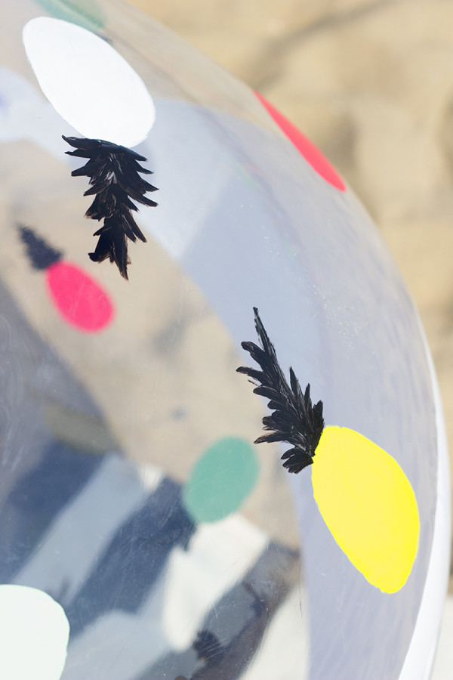
Image source: Studio DIY

Studio DIY gives you two ideas for decorating a plain beach ball, either pineapples or stipes. But you can pretty much follow your instincts and get creative with it! Whatever beach theme you love will make a beautiful and fun ball. Go for it!

Welcome Doormat
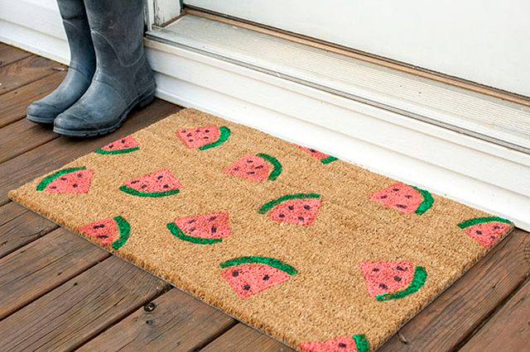
Image source: eHow

All you need for this adorable welcome mat are:

- A plain welcome mat
- 1 large, all-purpose sponge
- Sharp scissors
- Detail paintbrush
- Paint containers (plastic plates will do the trick)
- Pink, green and black paints

You are basically cutting two pieces of the sponge to mold your watermelon - one for the slice, and one for the edge. Then dip these pieces into the paint and apply it on your mat, you may need to do this twice - don’t be afraid to load up the paint! Allow it to dry for about 20 minutes and use the detail brush to add black dots that will work as watermelon seeds. After setting it aside to dry overnight, you can add a final coat of waterproof spray paint to help protect the stamp you created during the summer.

Suncatcher
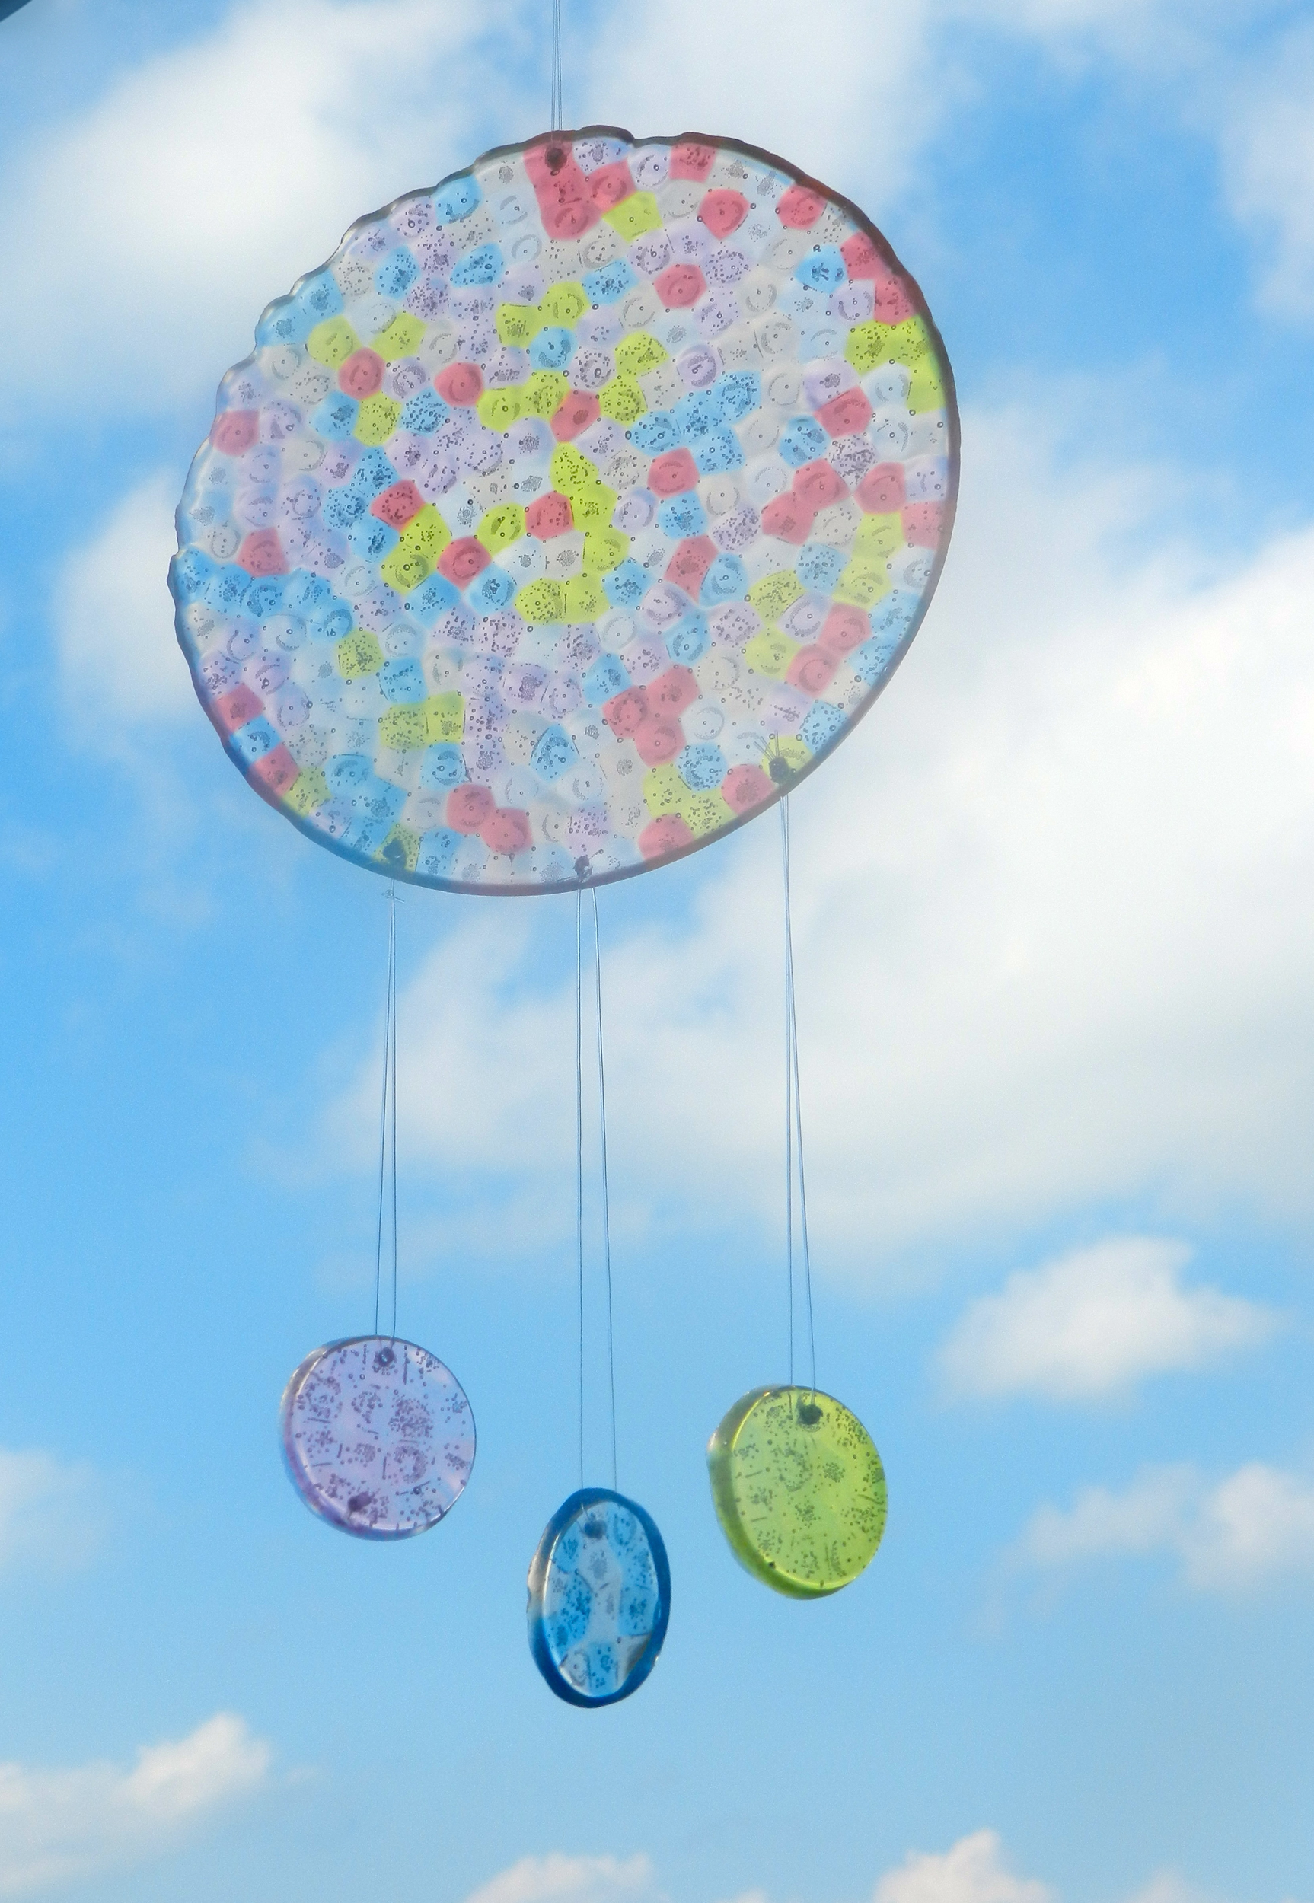
Image source: A Little Craft in Your Day

There is no doubt, people love suncatchers! They are so simple to make, and the results are wonderful. Not only suncatchers, but also dream catchers are guaranteed fun - and they help keep the bad dreams away! Find the DIY tutorial here.

Bubble Blowers
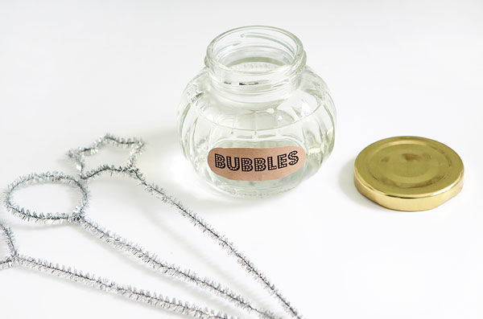
Image source: Hello Bee

When all those sunny, summer days are just waiting for you to come outside and enjoy the nice weather, bring along some homemade bubble solution and blowers for some good clean fun...get it? Clean fun...okay, okay. I’m getting carried away. But is a great summer craft for you and your children and/or grandchildren. It’s such a relaxing activity and the whole family can make use of it while taking a break from playing summer games.

Article written by Diana Lopes & Clearissa Coward, who are both writers for homeyou.com, where you can find decor and remodeling ideas, and professional contractors for any home improvement project. Join us on Facebook and Pinterest and happy summer!!

